Task 1
- Create a new catalog on a disk for storing infobases, name it 1C_Bases
- Create a new infobase inside this catalog, name it “Lesson1_Base1”.
- Load a configuration from the file “Lesson1_Configuration1.cf” and update infobase configuration
- Run this infobase at 1C:Enterprise mode and add 1 element (give it any name you want) to a catalog Products
- Dump the infobase to a file “Lesson1_Base1.dt”
- Create a new infobase “Lesson1_Base2”
- Restore the infobase from a file “Lesson1_Base1.dt”
- Run the infobase #2 and check that the product from the infobase #1 exists
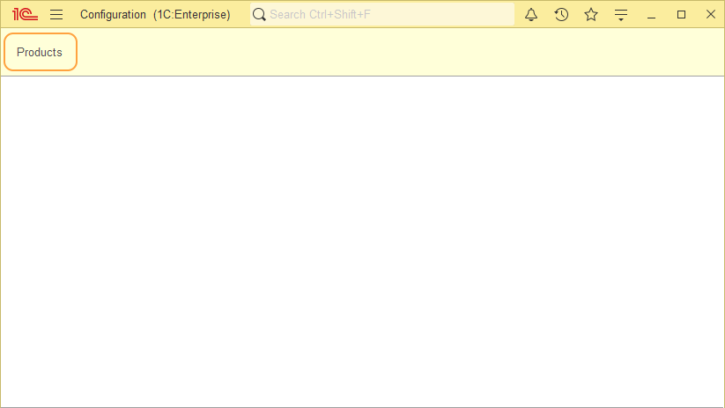
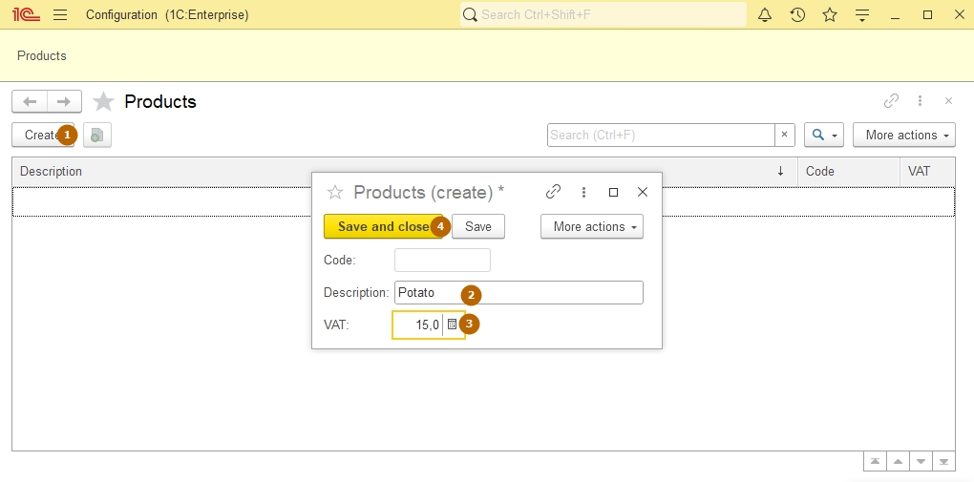

Task 2
- Delete the infobase Lesson1_Base2 from a list
- Add an existing infobase Lesson1_Base2 to the list
- Run an infobase Lesson1_Base2 at 1C:Enterprise mode and check if it works correctly
- Add an existing infobase Lesson1_Web published on a web-server. Address: https://demo.1c.com.vn/CM_MasterClass
- Run an infobase Lesson1_Web at 1C:Enterprise mode at thin client and at web-client (paste address of an infobase to an internet browser and go to the page) and compare these modes of connection.
- Add an existing infobase Lesson1_Server published on 1C:Enterprise server. Server clusters: DemoServer, name of infobase: Lesson1_Base2
- Try to run an infobase Lesson1_Server (you will get an error, because there is no server clusters “DemoServer” at your network)

Task 3
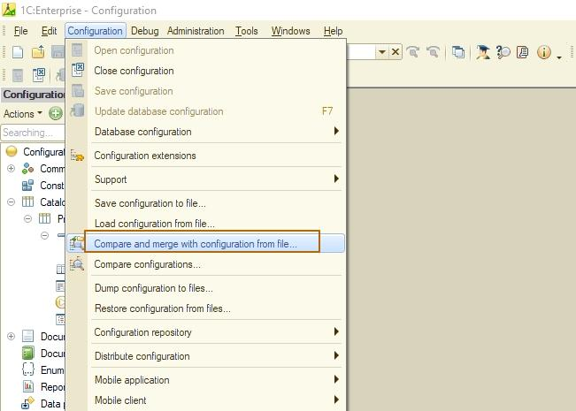
- Run the infobase Lesson1_Base1 at designer mode.
- Go to “Configuration” – “Compare and merge with configuration from file” and select configuration file “Lesson1_Configuration2.cf”
- Check the correctness of data at opened window in accordance with the image below, uncheck “Save settings automatically” box, click “Execute” and “Ok” after merging.
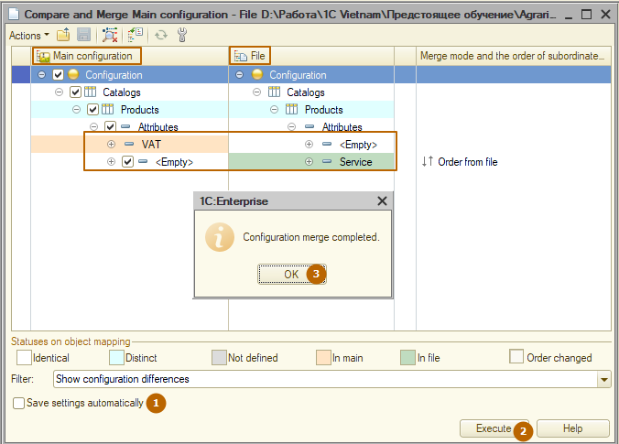
- Update database configuration (you may use F7)
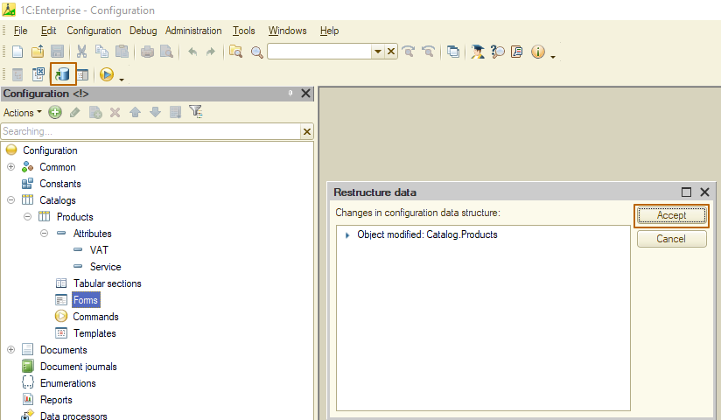
- Run the infobase at 1C:Enterprise mode and open a form of a product created earlier. Check the new attribute “Service”. It may be that the attribute is not visible, but there’s a scrollbar on the form:
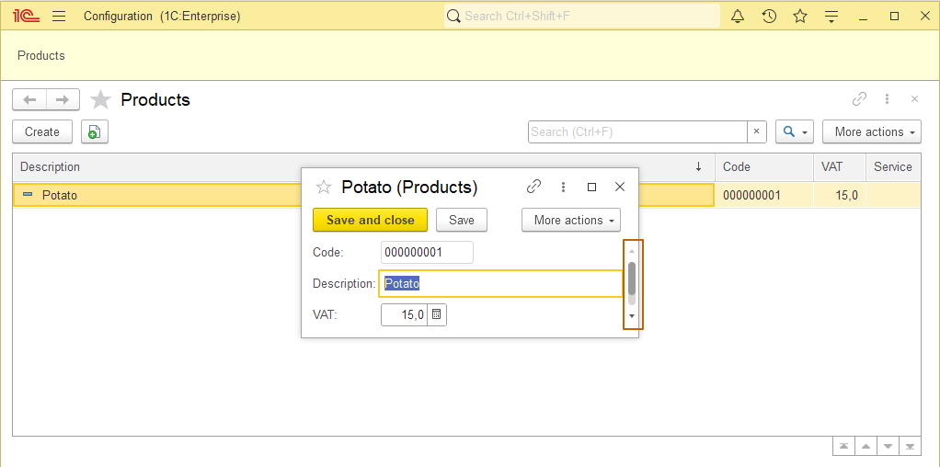
- It could happen because 1C:Enterprise uses cache for work with infobases and it remembers window size of forms. If so then click on “Menu” button – “Window” – “Restore window position”:
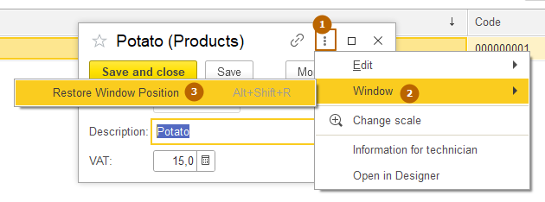
The form cache will be cleared and the form will be rebuilt. Now you can see new attribute “Service”:
